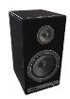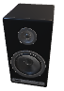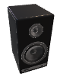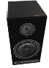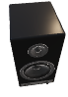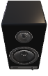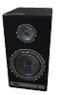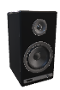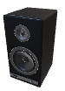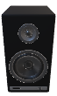

**Bookshelf Speakers**

Stereo Amplifier powering L/R Speakers

Mounted on wall (2.5m High)

with powered Subwoofer on floor

***Normally Choir/Positiv Division***

**Ahlborn Organ Console**

L/R Full-Range

Set of Speakers

***Normally Great/Hauptwerk Division***

**Tower Speakers**

L/R Studio Monitors

(Self Powered)

Mounted on beam in Tower (3.5m High)

***Normally Swell/Schwellwerk***

***& Solo Divisions***

**Pedal Speakers**

Powered Subwoofer with crossover

feeding upper frequencies to

Self-Powered L/R Studio Monitors

***Normally Pedal Division &***

***16’ Manual Ranks***

**Hauptwerk Routing Options:**

* **Clean** (Samples passed directly to outputs, no reverb)
  + - *Allows for DAW/Hardware Control & Effects*
* **Stereo Master** (Stereo Mix to All Channels)
* **2-Manual: Wet/Dry** (Reverb/Surround to Bookshelf)
* **3-Manual: Integrated Surround**
  + - *Choir/Positiv to Bookshelf*
    - *Reverb/Surround to Opposing Channels*
* **3-Manual: Isolated Surround**
  + - *Choir/Positiv to Tower*
    - *Reverb/Surround to Bookshelf Speakers*
* **4-Manual: Integrated Surround**
  + - *Solo to Tower Choir/Positiv to Bookshelf*
    - *Reverb/Surround to Opposing Channels*
* **4-Manual: Isolated Surround**
  + - *Solo to Tower & Choir/Positiv to Tower*
    - *Reverb/Surround to Bookshelf Speakers*
* **Comprehensive Surround** *(for sets w/6-channel surround)*